**BondAppétit Whitepaper**

**1. Introduction  
1.2 Market Problems  
2. Overview of the Protocol   
3. Appetit Balanced Token (ABT)  
3.1 Collateral Assets  
3.2 Stablecoin Generation**

**3.3 Liquidity Pools and Additional Capitalization of the Protocol**

**3.4 Interest Payouts & Incentivization Mechanics**

**3.5 Target Audience  
4. Key Actors, Borrowing Process and Risks  
5. Appetit Reward Token (ART)**

**5.1 Decision-Making Mechanisms Using ART  
5.2 Profit Distribution  
6. Technology  
6.1 Price Oracles  
6.2 Emergency Oracles  
6.3 Woodpecker Service   
6.4 Cryptocurrency Exchanges**

**6.5 Depository Smart Contract**

**6.6 Liquidity Pools  
6.7 Description of Key Methods in the Protocol  
7. Legal  
8. The Future of the Protocol**

# **1. Introduction**

Since the invention of Bitcoin in 2008, the crypto market has been introduced to more than 4000 cryptocurrencies. The market capitalization of Bitcoin equals $117.81 billion in 2020[1], while the total market capitalization of the crypto overcame the $300 billion mark[2] and is expected to grow even further. However, the market is isolated from traditional finance and there is a lack of instruments tied to real profitability.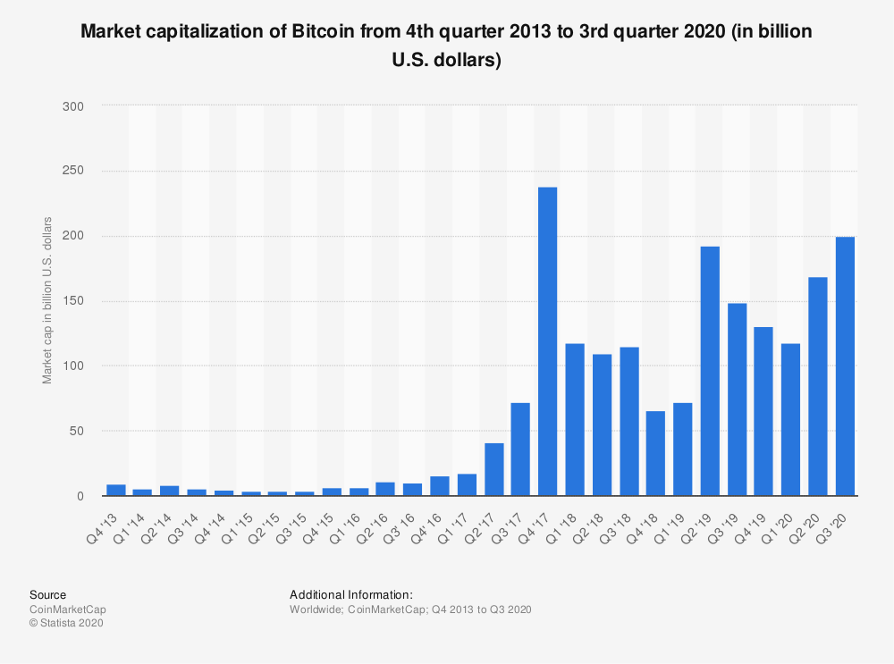

## **1.2 Market Problems**

As nearly all assets on the crypto market suffer from high volatility, it seems to be a logical starting point. During 2020 alone, the price of Bitcoin has suffered a 53% loss and then gone up 57,4%.[3] Sure, this year has been rather unusual but the market situation was even more radical in 2019, let’s see the real price in USD now: the BTC price has gone up from $5 167 on April 15 to $10 907 on June 27 only to drop to $7 980 on October 7. [4] And the situation was similar in 2018 with a significant drop in price after Bitcoin boom in December 2017.

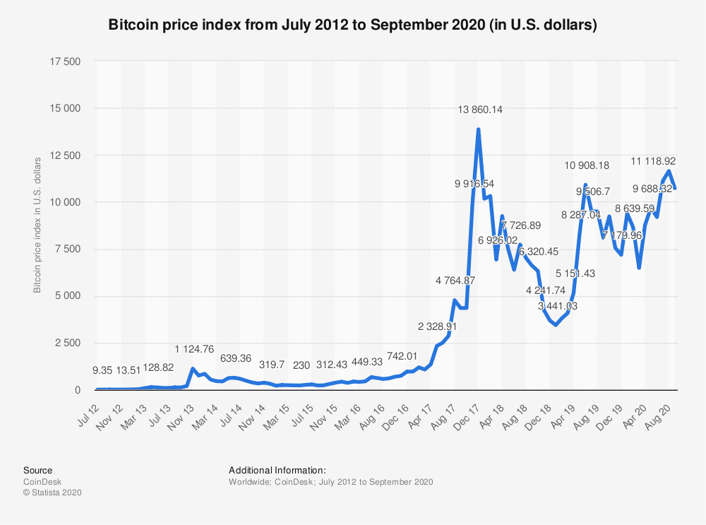

A solution to both volatility and lack of ties to real-world assets came in a form of stablecoins. Originally pegged to fiat money or exchange-traded commodities such as precious metals, stablecoins were presented as crypto-assets designed to not fluctuate in value — a safer option for investors looking to minimize their financial risks. In 2020, the market capitalization of stablecoins overcame the $20 billion mark.

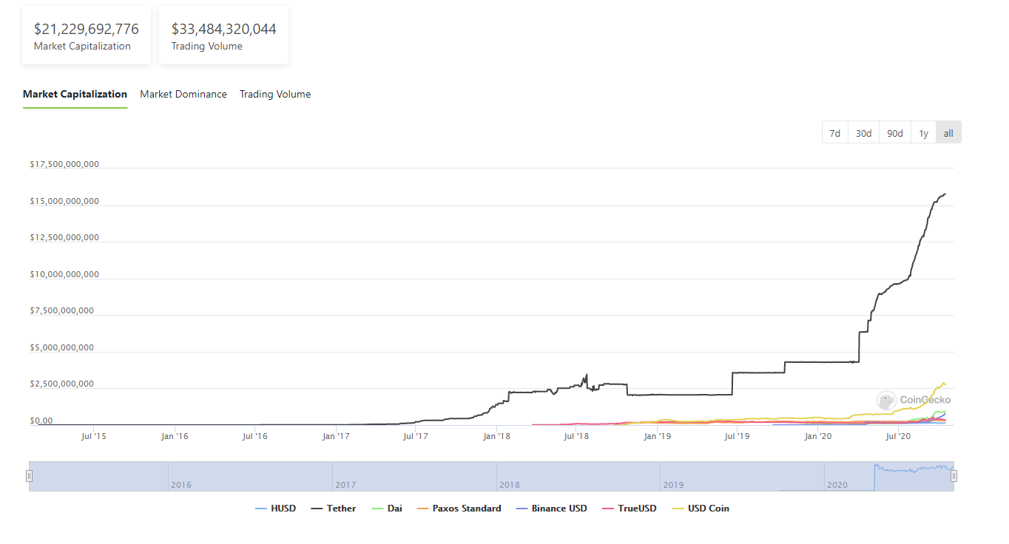[5]

However, there have been several cases when stablecoins turned out to be a bit volatile. The first case is Tether, the company behind the largest stablecoin backed by the US dollar on the market, faced accusations of being unable to provide audits for their reserves while continually issuing new coins into circulation. Then, in October 2018, Tether price dropped below the value of its underlying asset, USD, when in theory it should worth exactly $1.

Later, new types of stablecoins emerged — Crypto-Collateralized. Rather than being backed by fiat, crypto-collateralized stablecoins hold currencies such as Ether ($ETH) in escrow for the issuance of new tokens. In doing so, users have the ability to mint and burn tokens without needing to utilize or trust a centralized third party.

However, there is a major drawback — over-collateralization to account for price volatility. Most commonly, this ratio is set at 150%, meaning that in order to issue $100 worth of a certain stablecoin, you will need to post at least $150 worth of ETH as collateral.

In March 2020, the most popular crypto-backed stablecoin DAI failed to maintain its soft peg to the US Dollar. A sharp drop in the price of Ether — the primary digital asset used as collateral in the MakerDAO protocol for collateralizing loans of the dollar-pegged DAI stablecoin created underlying congestion on the Ethereum blockchain while also liquidating thousands of collateralized debt positions (CDPs) held by investors. As a result, investors lost $8.325 million. [6]

Another issue with the crypto market is lack of means to generate revenue tied to real profitability. In the traditional economy, depositing funds to savings account or purchase of fixed-income securities will bring you guaranteed income simply for holding an asset. Sure, there are risks, but holding stablecoins without any income seems to be even riskier with no reward for holding an asset.

The most recent change in this regard came with the emergence of Decentralized Finance (DeFi)[7]. However, with the DAI case in mind, protocols will require over-collateralization as there are no guarantees with such a volatile market. This leads to a situation where many of the protocols won’t actually work with a borrower unless they can effectively front a significant amount of assets, which undermines the essential function of borrowing.

But even with the current flaws, stablecoins have proven to be the backbone of the crypto market ensuring safekeeping of funds during periods of high volatility. Decentralized Finance has provided a wide range of ways to benefit from crypto for investors, we’ve seen an emergence of new exciting assets and projects.

At the same time, DeFi has a gigantic potential to start a revolution in the business loan market. On the other side of the table, there are borrowers that are willing to take the best of DeFi infrastructure and benefit from a loan at terms that no traditional venue can offer. These same borrowers can also provide a missing piece in the DeFi infrastructure — a wide range of low-volatility assets can be provided as collateral.

**With that in mind, meet a decentralized protocol that connects real-world debt instruments with the Ethereum ecosystem** — **BondAppétit. We provide an extra layer of stability and connection with fiat cash-flows mixed with fixed periodic income — something no other DeFi protocol can offer.**

Whole new collateral on the crypto market in the form of debt securities (bonds) — a financial instrument that has been used to preserve savings for decades.

BondAppétit offers a unique opportunity for investors to benefit from both income generated by the collateral that lies inside the protocol and interest payments paid by borrowers. Simultaneously, we are aiming to offer DeFi borrowing to real gourmets of the financial world.

***The secret of our cuisine is simple — we want to serve exquisite products to the crypto world by creating a perfect blend of traditional and crypto products.***

# **2. Overview of the Protocol**

BondAppétit is based on the Ethereum blockchain and provides a wide range of unique features:

* Real-world collateral (debt instruments);
* The infrastructure that connects decentralized finance and traditional debt instruments, with the participation of regulated securities and cryptocurrency broker/dealers;
* Use of real-world debt obligations (and corresponding interest payments) within the protocol to provide real fiat cash-flow to governance token liquidity pools.

It also includes all standard DeFi features:

* Ethereum-based smart contracts;
* Stablecoin tied to assets of the protocol;
* Community-owned Governance token — value of which grows along with the profit of the protocol and its development;
* Incentivization mechanisms for the community, including the distribution of protocol’s profits and support of liquidity providers.

Together with mentioned features, BondAppétit utilizes the best elements of on-chain and off-chain infrastructure to provide the new instrument that will allow to diversify risks and receive passive income:

|  |  |
| --- | --- |
| **On-Chain** | **Off-chain** |
| Use of open-source components from Compound Governance, Compound Open Price Feed | Use of traditional securities accounting systems for collateral locking |
| Price and Security Oracles | Use of bank and brokerage accounts for fiat and securities settlements |
| Listing on exchanges and use of liquidity pools, such as Uniswap, Curve, SushiSwap, Balancer | Connection to Bloomberg terminal and other securities pricing sources |

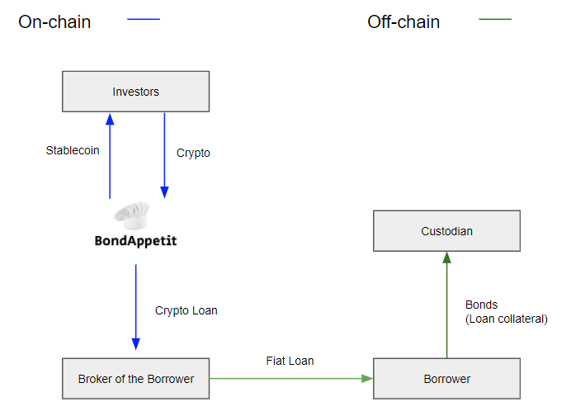

The main asset inside the protocol’s ecosystem is the stablecoin — Appetit Balanced Token (ABT). The price of ABT equals $1 at all times, while the token is issued only if the protocol has sufficient collateral. Information regarding the collateral can be checked through blockchain at all times. The ABT price is balanced automatically based on a basket of real-world debt obligations that form part of the protocol’s assets.

The process of borrowing is built in the most convenient way for a borrower in order to ensure compliance with regulatory and financial requirements with the conclusion of an appropriate agreement, which allows providing funds in fiat as well as crypto.

# **3. Appetit Balanced Token (ABT)**

As mentioned in the overview of the protocol, the main asset inside the protocol’s ecosystem is the Real World Asset-Backed Stablecoin — ABT.

The price of ABT equals $1 at all times and is balanced automatically based on a basket of real-world debt obligations that form part of the protocol’s assets. Information about the protocol’s assets is provided by oracles connected to custody accounts where the collateral is held. Issuance of the stablecoin is technically impossible without sufficient collateral, the price of which is tied to USD.

Outside of providing a whole new product for DeFi and traditional markets, we aim to make ABT one of the most popular stablecoins on the market.

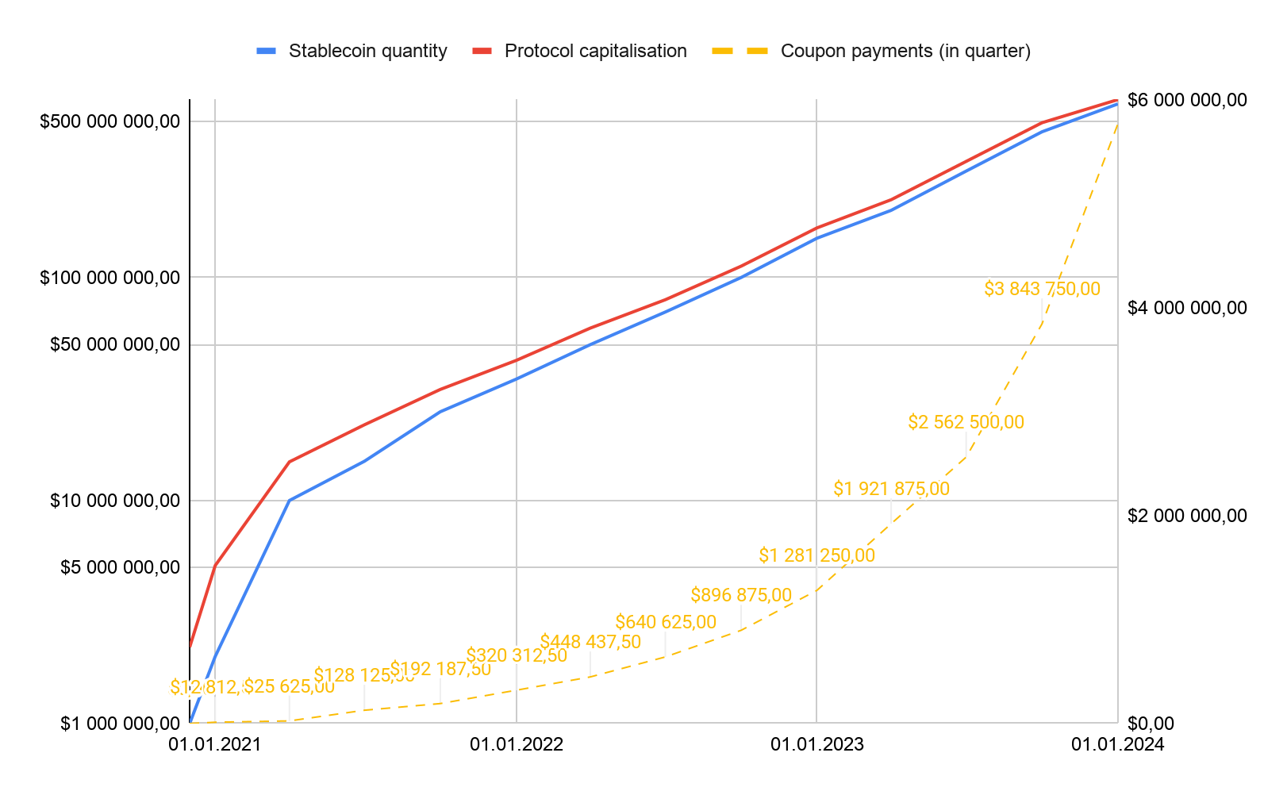

The use of real-world debt obligations allows the protocol to earn fixed periodical income, which can be distributed to holders of protocol tokens under incentivization mechanisms established by the community.

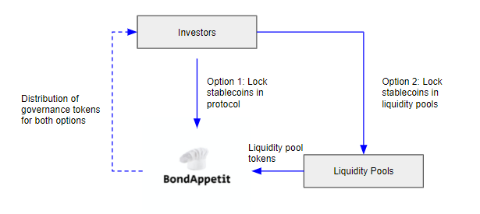

In order to ensure the stability of the protocol, the price of ABT is based on a basket of several debt obligations with different terms, interest rates, and redemption dates.

## **3.1 Collateral Assets**

In the foundation of the protocol lies a new type of asset — fixed income securities (hereinafter - collateral). The use of such asset type prevents the protocol from over-collateralization and ensures the stability of the asset even in times of high volatility on the crypto market. Initially, the protocol will collateralize strictly fixed income securities of stable companies.

**Corporate Bonds Market Overview**

As of August 2020, the overall size of the global bond markets in terms of USD equivalent notional outstanding is approximately $128.3tn. This consists of $87.5tn SSA bonds (68%) and $40.9tn corporate bonds (32%). Collateral assets are part of the corporate bonds market.

The global corporate bond markets are dominated by the US ($10.9tn) and China ($7.4tn). Between them, they make up 45% of the total global corporate bond market. 53% ($21.5tn) of outstanding corporate bonds are issued by financial institutions.

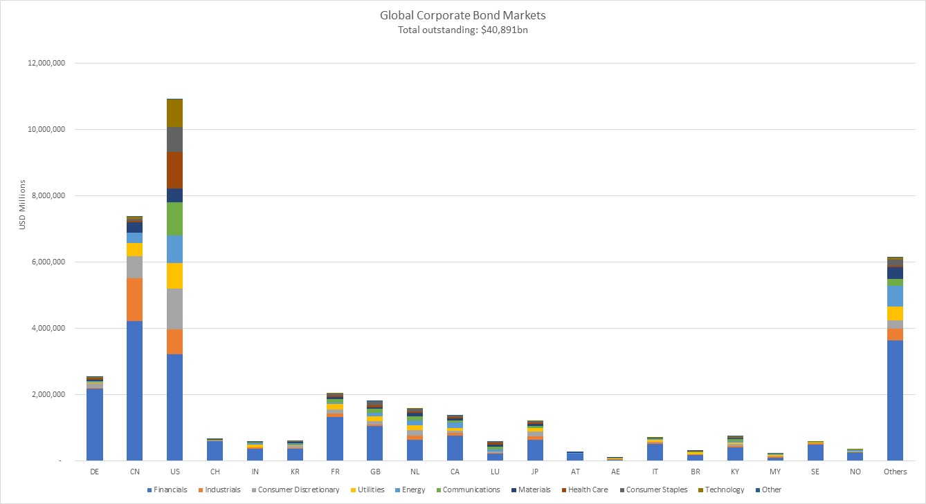

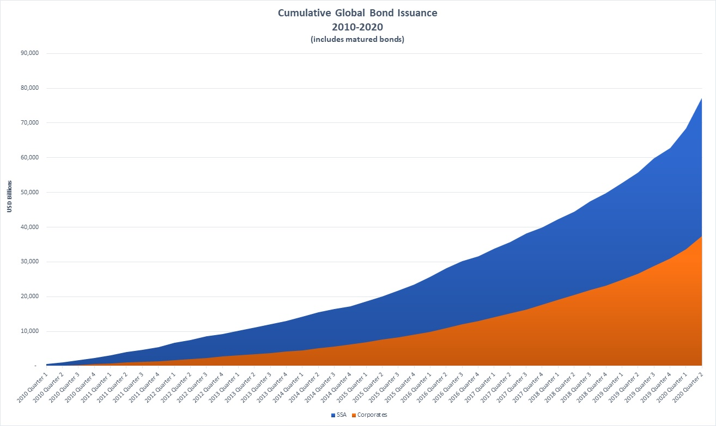

To ensure transparency, the protocol updates the price of real world-assets hourly based on several proven and recognized sources such as Bloomberg and CBonds (for detailed process please check section 6.1 — Price Oracles). Simultaneously with the update, the protocol publishes the price to the oracle and activates the security protocol. In the event of a significant change in asset price, the protocol might initiate additional capitalization or emergency shutdown.

## **3.2 Stablecoin Generation**

The protocol constantly monitors the overall value of the collateral and issues new ABT right after collateralization of new assets, based on the following formula:

* — the amount of stablecoins that the protocol can issue additionally if the value of collateral provided by borrowers is sufficient
* — an infinite number of assets in the basket
* — the market value of the collateral

**Example:**

100 Debt securities were added as collateral by borrower 1 with a value of $95

100 Debt securities were added as collateral by borrower 2 with a value of $105

The protocol requests the asset price from the price oracle and then issues the amount of ABT that equals the overall value of the collateral.

As a result, the protocol will issue: $95 + $105 = 200 ABT

## **3.3 Liquidity Pools and Additional Capitalization of the Protocol**

**Liquidity Provision** — Sufficient liquidity and the ability to exchange ABT for another liquid asset are vital for the correct operation of the protocol. Initially, the protocol will provide its own liquidity pool on the Uniswap exchange. The protocol has chosen Uniswap in order to provide an opportunity to exchange ABT for any other asset to all participants of the protocol (including automatic protocols).

As soon as the participation of the protocol’s community in liquidity pools will be sufficient, the protocol will reduce its participation in liquidity pools. In order to stimulate participation in liquidity pools, the protocol provides the reward in governance tokens — Appetit Reward Token (ART) (the list of liquidity pools is determined by the community of the protocol).

**Additional Capitalization** — The protocol might require additional liquid assets in order to ensure future development and operations. For these cases, the protocol has the scenario of selling governance tokens from the protocol’s reserves. In this scenario, ART will be sold following the procedure below:

1. Private offering of ART below the market price to current ART holders. Funds will be locked until the end of the additional capitalization round. This scenario will allow current users to increase their share in the project, additionally providing the funds needed for the protocol. At the same time, users won’t be able to purchase a higher amount of ART than they already own.   
     
   The formula for determining the available amount of ART for current tokenholders:

* — Amount of funds required by the protocol;
* — Amount of governance tokens in tokenholder’s wallet;
* — Overall amount of governance tokens on the market.

The formula for determining the price of governance tokens for current tokenholders:

* — Market price for governance tokens on the Uniswap exchange
* — Discount percentage that is determined by the community of the protocol.

Since current tokenholders acquire governance tokens at the discounted price, they receive clear benefits after selling the asset at the market price.

1. A public offering of ART at the market price through public exchanges. In this case, governance tokens are sold through an intermediary at the market price without any quantitative restrictions.

**Treasury**In order to attract new borrowers, the protocol will require the involvement of intermediaries. As intermediaries charge fees for their operations, the protocol will require a budget to cover these costs.

These fees originate due to the fact of transferring loan amounts from the fiat world to crypto and vice-versa and may vary from 2-3.5% of the loan amount covering the services of banks, brokers, and exchanges involved in the process.

In order to compensate for these, the protocol creates a special pool called Treasury. The pool is formed through the offering of ART and by the allocation of the protocol’s profits (decided by the community of the protocol). Prior to forming a pool, the protocol indicates the target amount and expiration date.

Funds can be withdrawn from the pool after one of the conditions below is met:

1. The target amount is raised;
2. The offering has reached its expiration date.

If conditions are met, the community of the protocol votes on the withdrawal of funds from the treasury. After that, community members will be able to check the payment for intermediary services in order to ensure the transparency of the Treasury function.

## **3.4 Interest Payouts & Incentivization Mechanics**

The protocol provides reward mechanisms for participants in the form of ART. At the moment we have cooked 2 delicious Reward Mechanisms for our communauté gourmande:

**Locking ABT or ART in the protocol.**Using this method, the community of the protocol will receive reward per block in ART on account of continuous increase in price of special technical tokens.

**Participate in a liquidity pool that includes ABT/ART on Automated Market Maker-based (AMM) decentralized exchanges and centralized exchanges.**

Using this method, the community of the protocol will receive reward per block on account of the continuous increase in the price of liquidity pool technical tokens.  
  
Liquidity pool technical tokens (LPT) — an ERC-20 technical liquidity pool token used for calculation of the reward. The reward is calculated through a change in token’s price per block, while the reward rate is decided by the community of the protocol.

**The price of a technical token is calculated using the formula below:**

* — Last price of the technical token prior to the last reward payout;
* — Current block;
* — The number of block of the last change in the reward rate;
* — Current reward rate.

**Example:**

**Protocol’s launch:**

LastChangeRewardBlock = 11060675

LPTPriceAccum = 1

Reward = 0,00000018

CurrentBlock = 11060688

LPTPrice = 1 + (11060688 - 11060675) * 0,00000018 = 1,00000234

The community has decided to change the Reward Rate from 0,00000018 to 0,00000050:

LastChangeRewardBlock = 11060688

LPTPriceAccum = 1,00000234

Reward = 0,00000050

CurrentBlock = 11060888

LPTPrice = 1,00000234 + (11060888 - 11060688) * 0,00000050 = 1,00010234

The reward for all methods is calculated using the formula below:

* — Profit in Governance Tokens;
* — The amount of ABT or ART tokens locked (locked amount is saved in smart contract);
* — Current price of liquidity pool technical tokens.

**Example:**

User locks 100 Stablecoins on the block 11060688 and receives 100 / 1,00000234 = 99,999766001 LPT.  
  
On the block 11060888 User decides to withdraw funds and receives   
0,009999977 = (99,999766001 * 1,00010234) - 100 in ART.

## **3.5 Target Audience**

The target audience of the ABT includes four types of investors: retail crypto investors, sophisticated crypto investors, institutional investors, and cryptocurrency exchanges.

|  |  |
| --- | --- |
| **Retail crypto investors** | |
| **Experience** | Investors come from a wide range of backgrounds; most are newcomers to intermediate trading |
| **Investment appetite** | Average investor could invest from $1000 to $5000 |
| **Motivation** | Investing in a crypto asset that is backed by traditional collateral and has stable fixed income with several other incentivization mechanisms inside the protocol |

|  |  |
| --- | --- |
| **Sophisticated crypto investors** | |
| **Experience** | Investors that have advanced trading experience and rely on data market and analytics provided by professional brokers |
| **Investment appetite** | Average investor could invest from $5000 to $10 000 |
| **Motivation** | Investing in a crypto asset that is backed by a traditional collateral |

|  |  |
| --- | --- |
| **Institutional investors** | |
| Institutional investors are currently paying close attention to the crypto market in general and DeFi in particular. Taking this into consideration, the offering of stablecoin backed by traditional assets of reputable large-scale companies could potentially spark huge interest among institutional investors | |

|  |  |
| --- | --- |
| **Cryptocurrency exchanges** | |
| Holding large amounts of volatile cryptocurrencies, crypto exchanges could potentially welcome the opportunity to invest part of their BTC funds in a stablecoin that is backed by a traditional regulated fixed-income asset | |

# 

# 

# 

# 

# 

# 

# 

# 

# 

# 

# 

# **4. Key Actors, Borrowing Process and Risks**

There are two mechanisms available in order to borrow funds from the protocol. Both require the use of intermediaries’ services which allow ultimate borrowers to lock real-world assets as collateral and obtain funding.

This section describes the process of whitelisting intermediaries as well as the ultimate borrowers, and details both mechanisms mentioned above.

**Intermediaries and borrowers**

Intermediaries assume the key role in terms of connecting protocol with real-world assets.

The main function of the intermediary is to find new borrowers, who are willing to lock their debt securities in order to obtain liquidity from the protocol.

Intermediaries must satisfy the following basic requirements in order to be able to interact with the protocol:

1. Holding of 1%[8] of the total amount of issued Governance tokens and locking this amount in protocol’s smart contract;
2. Approval by majority voting of Governance token holders and whitelisting by the protocol.

In addition to the basic requirements, the community may establish additional requirements to be fulfilled by the intermediaries, which will be published on the protocol’s website. Such requirements include:

* Financial Intermediary License and supervision from regulators;
* Insurance;
* Internal audit;
* Ability to exchange cryptocurrency to fiat and vice-versa in compliance with applicable regulations.

In order to perform their functions, intermediaries must take into account the requirements established by the community of the protocol, such as:

1. The amount of funds which protocol is willing to make available to be borrowed;
2. Interest rate which has to be paid to the protocol;
3. The loan term.

Once the information above is available, the intermediary finds a borrower who needs to satisfy the following requirements:

* The borrower must own debt securities the price of which would cover the amount indicated in section 1 above;
* The interest rate on debt securities shall be at least equal to the interest rate established in section 2 above;
* The redemption period of debt securities must match the term of the loan indicated in section 3 above.

**Custodians**

The main function of the custodian is to provide a custody account in traditional securities accounting systems that are used to safekeep debt securities.

Ancillary functions include:

* Informing the protocol and the community on the amount of debt securities held on the custody accounts;
* Participation in settlements between the borrower and the intermediary.

The custodian must fulfill the following requirements:

* Regulated under securities markets regulation with ability to provide custody services to the clients;
* Approved by majority voting of Governance token holders and whitelisting by the protocol;
* Must be able to technically exchange information with the protocol.

**Borrowing process**

There are two mechanisms available in order to borrow funds from the protocol.

The difference between them lies in the legal structure of the deal between the borrower and the intermediary. Depending on the chosen structure, the protocol can be more or less reliant and protected from the actions of the intermediary, resulting in different levels of risks.

Both mechanisms, as well as corresponding risks and mitigation measures, are described below.

***Mechanism 1: Loan agreement***

1. **Borrowing**
2. The borrower enters into a loan agreement with the intermediary, providing debt securities as collateral.
3. Securities are transferred to a custody account opened by the custodian, who ensures that the collateral cannot be transferred for the term of the loan.
4. The agreement also provides that in the event of a borrower's default, the intermediary is entitled to receive the collateral and sell it.
5. Custodian transmits information about the amount of collateral to the protocol.
6. Stablecoins are issued by the protocol and sold to the market in return for cryptocurrency which is stored in the protocol.
7. The intermediary borrows the cryptocurrency from the protocol and converts it into fiat.
8. The intermediary lends the fiat to the borrower under the loan agreement.

**B. Interest Income**

1. The borrower continues to own the securities (even though unable to sell them as they are locked into the collateral custody account) and receive interest income.
2. The borrower uses interest income received on debt securities to pay interest under a loan agreement with the intermediary.
3. The intermediary converts payments received from the borrower to crypto and makes corresponding payments to the protocol.

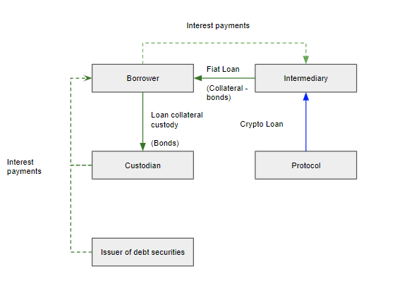

**C. Risks for the Protocol**

Under this mechanism, the protocol is less vulnerable against the actions of the intermediary, as debt securities are locked on the custody account and the intermediary is not able to freely dispose of them.

However, once the borrower has repaid the debt to the intermediary, there is still a risk for the protocol that the intermediary will not repay his part to the protocol.

In order to mitigate this risk, the following measures are undertaken:

1. The intermediary is preselected and whitelisted by the community to ensure that only reputable entities are allowed to borrow from the protocol;
2. Governance tokens locked by the intermediary in the protocol prior to taking the loan, cannot be unlocked unless the intermediary fully repays the loan to the protocol.

***Mechanism 2: Sale and Purchase Agreement***

1. **Borrowing**
2. The borrower enters into a sale and purchase agreement with the intermediary under which the borrower sells debt securities to the intermediary with deferred payment.
3. Securities are transferred to a custody account opened by the custodian in the name of the intermediary. As opposed to the Mechanism 1, securities are in no way limited and remain at complete disposal of the intermediary.
4. Custodian transmits information about the amount of debt securities on the account of the intermediary to the protocol.
5. Stablecoins are issued by the protocol and sold to the market in return for cryptocurrency which is stored in the protocol.
6. The intermediary borrows the cryptocurrency from the protocol and converts it into fiat.
7. The intermediary transfers the fiat to the borrower in fulfillment of the deferred payment under the agreement.

**B. Interest Income**

1. The intermediary becomes the owner of the securities and receives interest income.
2. The intermediary converts payments received on the securities to crypto and makes corresponding payments to the protocol.

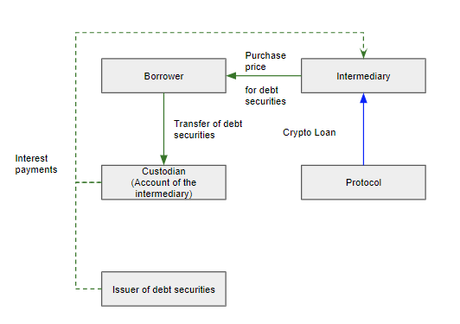

**C. Risks for the Protocol**

Under this mechanism, the protocol is more vulnerable to the actions of the intermediary, as debt securities are not locked and remain fully available to the intermediary.

In order to mitigate this risk, in addition to measures mentioned in the previous section, the intermediary must comply with all the requirements indicated in section “Intermediaries and borrowers” above.

## **Default**

In addition to the risks indicated above, the following non-payment risks can be applicable to the protocol despite the chosen borrowing mechanism:

* The default of the intermediary;
* The default of the borrower;
* The default of the custodian;
* The default of a debt security issuer.

# **5. Appetit Reward Token (ART)**

Governance is one of the most important foundational things for each DeFi protocol. From day one, BondAppétit aims to reach a fully decentralized governance structure using the best practices that have already proved efficient in other protocols. In order to achieve this, BondAppétit will be working to build a strong community that will become a driving force of the protocol for years to come.

The main tool for decision-making in the protocol is the Appetit Reward Token (ART), as well as the main reward and incentive tool for participants of the protocol and the community.

**Acquisition of ART:**

1. Can be acquired on the market (Uniswap or other exchanges) at market price;
2. Distributed by the protocol to those users who decide to lock their ABT/ART in the protocol’s smart contract (similar to DAI saving rate);
3. Distributed to those users who decided to lock their ABT/ART into liquidity pools and provide the protocol with liquidity pool tokens (similar to SushiSwap)
4. Purchase at a special price in case of additional capitalization of the protocol for current ART tokenholders (detailed explanation is available in section 3.3);

To ensure the inexhaustibly of ART — the protocol contains the ability to issue new tokens each block. The decision regarding the new issuance is taken is by voting of tokenholders.

**Initial Offering and Distribution of ART:**

* 12% to early investors and advisors, subject to a 1-year moratorium on sale;
* 2% to advisors, subject to a 1-year moratorium on sale;
* 20% BondAppétite team & future team members, subject to 4-year vesting;
* 14% to BondAppétite founders, subject to 18 months moratorium on sale;
* 1% to the pre-launch investor;
* 51% reserved for protocol usage and future governance participation incentives.

After issuance, tokens are distributed to investors' wallets. In order to ensure the moratorium on sale, the following restrictions will be set to wallets of investors **strictly during the moratorium period**:

1) The minimum balance of ART tokens on the wallet (is equal to the initial investment amount);

2) Intransferability of ART tokens from investors’ wallets.

Such a mechanism allows investors to participate in staking and voting, receive rewards in ART, while ensuring the fulfillment of moratorium on sale.

We understand that the availability of a higher number of governance tokens on the market might cause a significant drop in value, therefore all tokens distributed to the team at the project launch are locked in the protocol for 4 years according to the vesting schedule below:

|  |  |  |
| --- | --- | --- |
| **Year** | **Amount of tokens** | **Distribution (%)** |
| Q4 2021 | 800 000,00 | 40% |
| Q4 2022 | 600 000,00 | 30% |
| Q4 2023 | 400 000,00 | 20% |
| Q4 2024 | 200 000,00 | 10% |

## **5.1 Decision-Making Mechanisms Using ART**

ART holders are entitled to influence the future and features of BondAppétite. In order to enforce certain actions, a simple majority of tokenholders must vote for a certain proposal.

All features of the protocol divide into 3 categories:

|  |  |  |
| --- | --- | --- |
| **Protocol’s Management** | **Liquidity** | **Development of the protocol** |
| * Add a new asset type (collateral) to the basket; * Add a new asset type to the Price Oracle; * Whitelist a new Depository smart contract; * Start the emergency shutdown procedure; * Add new markets for the automatic exchange of ABT. | * Change in the reward rates for participation in liquidity pools; * Choose the profit distribution of the protocol; * Changing the list of assets available in exchange for ABT. | * Proposal and voting on new features of the protocol; * Change the rate of technical costs for the maintenance of the protocol; * Initiate additional capitalization of the protocol; * Apply changes to current smart contracts. |

# 

# 

# 

# 

# 

# **6. Technology**

While cooking the delicious technical stuffing of BondAppétit, we were inspired by a great work of developers from Compound, MakerDAO, Uniswap, and other protocols based on the Ethereum blockchain.

The current approach on the market consists of both pros and cons.

The main disadvantage, of course, is the unpredictability of the protocol’s fees. That’s why we’ve carefully structured our smart contracts utilizing the most up to date technologies with simple goals in mind — reduction in complexity of smart contracts that will result in reduction Gas fees. At the same time, we hope that the problem will be solved with the release of Ethereum 2.0.

Outside of using home-baked solutions only, we’ve also tried to utilize existing solutions to the maximum. ART token is based on the [Compound Governance](https://github.com/compound-developers/compound-governance-examples) system as it allows ensuring transparent and secure management of the protocol by the community. Additionally, Compound Governance adds new features, for example, it allows to delegate a vote to another participant.

For price updates, the protocol utilizes [Compound Open Price Feed](https://github.com/compound-finance/open-oracle) — an oracle that allows Reporters to sign price data using a known public key, which can submit on-chain. The protocol codebase is hosted on GitHub and maintained by the community.

Another significant aim during the development of the protocol lied in ensuring the maximum security of BondAppétit. In order to achieve this, developers of the protocol conduct regular audits of smart contracts both during development and after their implementation on the main network.

## **6.1 Price Oracles**

Price oracle is a tool for supplying data on the current price of the collateral. As BondAppétit uses fixed-income instruments as collateral, the actual asset price must be received from external sources such as Bloomberg, cBonds, direct APIs to exchanges. In order to ensure the correctness and reliability of the used price, the oracle calculates the median of all received prices first and only after that delivers it to the protocol.

## **6.2 Emergency Oracles**

Emergency oracle is a tool responsible for security of the protocol. Emergency oracles monitor the current value of the collateral, as well as market prices of ABT and ART. If the price of the collateral is insufficient to guarantee the stability of ABT, the protocol will initiate additional capitalization or emergency shutdown.

## **6.3 Woodpecker Service**

The open-source code tool that invokes main technical features of the protocol. This utility can be deployed by each user of the network. In order to do this, a user will need to generate a new wallet in the ETH network and form an initial balance of 0.5 ETH.

A fee for each transaction executed in the protocol will be automatically replenished through the **feeCompensation(txID)** method of the protocol.

## **6.4 Cryptocurrency Exchanges**

One of the key processes in the lifecycle of the protocol is the exchange of ABT for a liquid asset that will be later exchanged for fiat money through a public exchange. Thus, any exchange or protocol with sufficient liquidity can be used for exchange operations.

## **6.5 Depository Smart Contract**

Depository smart contracts are designed with one specific goal — provide the data on the collateral to the protocol and the community. In order to achieve this, a smart contract must ensure constant communication between the custodian and the protocol.

The protocol provides a separate smart contract for each custodian and each depository smart contract must be whitelisted by the community of the protocol. As soon as the smart contract is launched, the custodian is required to send information on the amount of collateral currently stored on the account. After the information is received, the smart contract publishes information on assets on the blockchain.

## **6.6 Liquidity Pools**

To ensure the liquidity of the ABT, the protocol utilizes liquidity pools on AMM-based decentralized exchanges and centralized exchanges. The reward in ART is allocated for maintaining the liquidity level in pairs associated with the protocol’s stablecoin. (For more details please refer to section 3.4).

## **6.7 Description of Key Methods in the Protocol**

**basketRebalance()** — One of the key methods that includes several vital processes of BondAppétit, including:

* The process of assessing the liquidity of the current basket used as collateral;
* Additional issuance of ABT;
* Issuance of ART on the market.

**checkDepositories()** —launch averification check that is aimed to identify new data from whitelisted depositories.

**feeCompensation(txID)** — the compensation of a fee spent on cooperation with whitelisted protocol contracts

**claimGToken()** — claim remaining ART allocated as a payout to a user

**guardPush()** — a regular check that ensures the control over the execution of critical processes in the protocol. In particular, this method ensures that:

* The protocol receives data from the price oracle at least every 24 hours;
* The last update **checkDepositories()** was launched within 24 hours prior to launching the **basketRebalance()** method.

This method is able to launch the emergency shutdown procedure if one of the conditions above isn’t met.

# **7. Legal**

Tokens issued by BondAppétit have the following classification for legal purposes:

## **Appetit Balanced Token (ABT)**

Appetit Balanced Token does not have a legal issuer (as it is created by the protocol itself). The token represents the mean of transferring value, and it is defined as such exclusively by market participants. The token itself does not imply any obligations of the protocol or any of its participants.

Price stability is connected to the protocol’s assets, the price of which should always be close to the value of the ABT in circulation.

ABT owners do not possess any rights to assets of the protocol. Neither they have any legal mechanisms or rights to oblige the protocol or its participants to buy-back or redeem ABT or receive any other payments or assets from the protocol. The value or liquidity of ABT is not guaranteed, meaning that no individual or legal entity guarantees the acceptance of the token as payment for goods or services, its price, or the ability to exchange it for any other asset.

**Appetit Reward Token (ART)**

Appetit Reward Token does not have a legal issuer (as it is created by the protocol itself). The token represents the mean of transferring value, and it is defined as such exclusively by market participants. The token itself does not imply any obligations of the protocol or any of its participants.

The asset price is not stable and depends on two factors: the profitability of the protocol and expectation of the protocol’s growth. ART can be allocated by the protocol to ABT/ART owners, and can also be purchased on the market. The value or liquidity of the ART is not guaranteed, meaning that no individual or legal entity guarantees the acceptance of the token as payment for goods or services, its price, or the ability to exchange it for any other asset.

# **8. The Future of the Protocol**

Initially, developers of BondAppétite were driven by a simple and ambitious goal — providing DeFi borrowing from current protocols to traditional companies. However, the market right now is designed to work strictly with crypto assets and over-collateralization is a significant hurdle for traditional market players, even with all benefits of DeFi in mind.

That discovery led to the creation of BondAppétite. During the first development stage of the protocol, BondAppétite aims to provide sufficient liquidity for the protocol’s assets, build a strong community of the protocol, spread the concept of DeFi borrowing to the traditional market, and take a significant role in the DeFi market.

During the second development stage which is planned to start in 2022, BondAppétite aims to create a borrowing platform that will operate directly with issuers of fixed-income debt instruments. Therefore, providing access to traditional financial instruments in a fully decentralized manner. As a platform, BondAppétite will charge fees from the borrowers for each deal completed on the platform. Another feature that is vital for correct operations of the protocol on the second stage is the automated prediction system that will forecast asset price, calculate coupon payments and forecast possibility of default for each issuer.

The long-term goal of the protocol lies in building a stable bridge between traditional and decentralized finance. Such a goal can’t be achieved in short timeframes. Therefore, the launch of the protocol and first borrowers will only lay the foundation.

In the long-term, BondAppétit will allow increasing capitalization of crypto to a whole new level by tying it to the real-world assets which prices depend on the true performance of companies and traditional market situation. Simultaneously, the protocol aims to provide traditional financial market players with regulated and clear access to the whole crypto market. The first step to achieve this will be helping them utilize DeFi borrowing. In a 4 years perspective, BondAppétit aims to bring at least 0.1% ($40.8 billion) of the overall corporate debt securities market to the crypto market.

Right now the borrowing process includes intermediaries including custodians and brokers. As soon as regulation will allow to change the approach, BondAppétit will provide an opportunity for direct borrowing from the protocol, removing all intermediaries from the process in order to cut down costs of the protocol.

When it comes to the assets that form BondAppétit, the initial plan is to be listed on all major crypto exchanges by the Q3 2021 and reaching the capitalization of $50M by the end of 2021.

Original developers of the protocol are true believers in utilization of the blockchain technology and most importantly in the crypto market. Therefore, as new types of traditional assets will emerge in the form of tokens (security tokens, tokenized securities), BondAppétit will be looking forward to using them as collateral instead of the same assets in the traditional form.

With all these ideas in mind, we would like to present you the Roadmap of BondAppétite:

|  |  |  |  |  |  |  |  |
| --- | --- | --- | --- | --- | --- | --- | --- |
| **Q4 2020** | **Q1 2021** | **Q2 2021** | **Q3 2021** | **Q1 2022** | **Q2 2022** | **Q1 2023** | **Q2 2023** |
| **Protocol launch** | **2 separate debt obligations provided as a collateral** | **Reach $10 000 000**  **in capitalization of the protocol** | **5 separate debt obligations provided as a collateral** | **Reach $35 000 000**  **in capitalization of the protocol;** | **Listing on centralized and decentralized exchanges** | **Reach $150 000 000**  **in capitalization of the protocol** | **Reach $600 000 000**  **in capitalization of the protocol** |

1. https://www.statista.com/statistics/377382/bitcoin-market-capitalization/#:~:text=The%20market%20capitalization%20of%20Bitcoin,circulation%20by%20the%20Bitcoin%20price.
2. https://coinmarketcap.com/charts/
3. https://coinmarketcap.com/currencies/bitcoin/historical-data/?start=20200406&end=20201006
4. <https://coinmarketcap.com/currencies/bitcoin/historical-data/?start=20191007&end=20191007>
5. https://www.coingecko.com/en/stablecoins
6. https://www.coindesk.com/makerdao-users-sue-stablecoin-issuer-following-black-thursday-losses
7. Decentralized Finance (DeFi) is an open finance infrastructure that allows investors to earn fixed periodical income by lending or holding their assets via DeFi protocols.
8. This amount can be subject to changes by the community of the protocol